Grade 11: Conditional Probability - YouTube
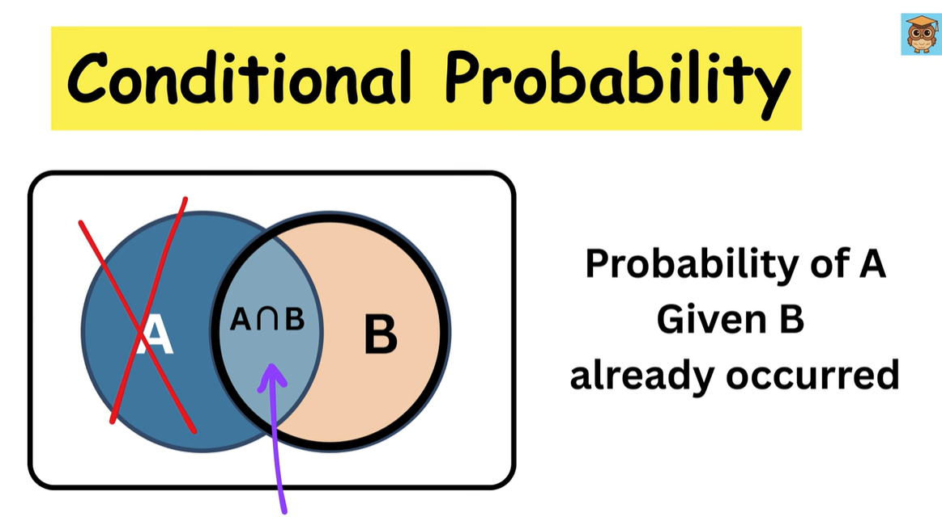
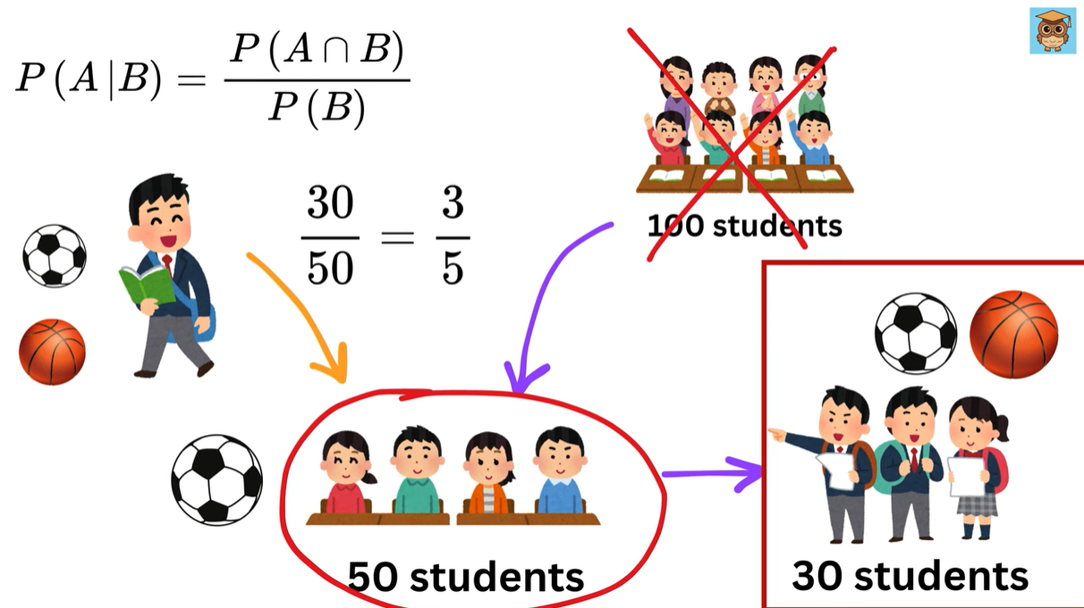
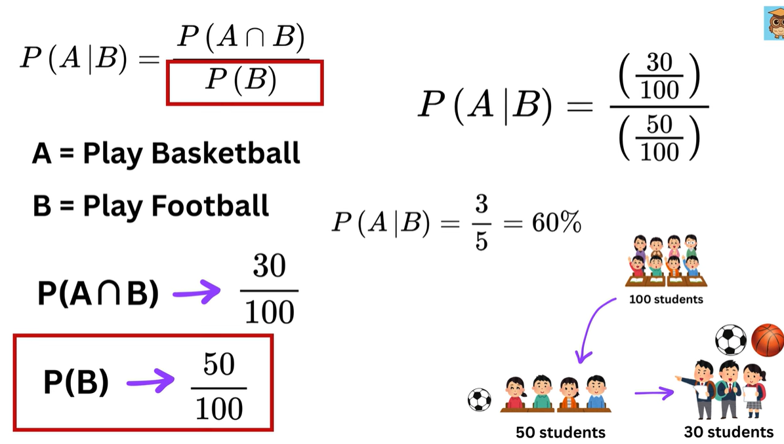

Exercise 2 (with short explanations) followed by two similar practice problems you can try.
Exercise 2. In a lot of 10 elements, there are three defectives. Two elements are selected at random and without replacement, one after another.
(i) What is the probability that the first is good, and the second is defective? (ii) What is the probability that the second is defective? (iii) What is the probability that the second is defective given the first one is good? (iv) What is the probability that the first one is good given the second is defective?

Given
Lot of 10 elements, 3 defectives (D) and 7 good (G).
Two elements are selected at random without replacement, one after another.
Let events:
- $G_{1}$= first is good, $D_{1}$= first defective.
- $G_{2}$= second is good, $D_{2}$= second defective.

(i) $P(\text{first is good and second is defective})=P(G_{1}∩D_{2})$
We compute sequentially:
$$P(G_{1}∩D_{2})=P(G_{1})⋅P(D_{2}∣G_{1})=\frac{7}{10}⋅\frac{3}{9}=\frac{21}{90}=\frac{7}{30}≈0.2333.$$

(ii) $P(\text{second is defective})=P(D_{2})$
Use total probability (or symmetry/exchangeability argument: any draw has same chance of being defective = 3/10):
Compute two ways:
Way A (total probability):
$$P(D_{2})=P(D_{2}∣D_{1})P(D_{1})+P(D_{2}∣G_{1})P(G_{1}).$$
Here $P(D_{1})=3/10, P(D_{2}∣D_{1})=2/9$and $P(G_{1})=7/10, P(D_{2}∣G_{1})=3/9$.
$$P(D_{2})=\frac{3}{10}⋅\frac{2}{9}+\frac{7}{10}⋅\frac{3}{9}=\frac{6}{90}+\frac{21}{90}=\frac{27}{90}=\frac{3}{10}=0.3.$$
Way B (symmetry): because draws are random without replacement, each position has same marginal chance of being defective $=3/10$.
So $P(D_{2})=\boxed{3/10 (0.3)}$.

(iii) $P(\text{second is defective}∣\text{first is good})=P(D_{2}∣G_{1})$
After a good is removed, remaining: 9 items, 3 defectives.
$$P(D_{2}∣G_{1})=\frac{3}{9}=\frac{1}{3}≈0.3333.$$

(iv) $P(\text{first is good}∣\text{second is defective})=P(G_{1}∣D_{2})$
Use Bayes / conditional definition:
$$P(G_{1}∣D_{2})=\frac{P(G_{1}∩D_{2})}{P(D_{2})}=\frac{\frac{21}{90}}{\frac{27}{90}}=\frac{21}{27}=\frac{7}{9}≈0.7778.$$
(Interpretation: given the second drawn is defective, it's quite likely the first was good because there are more goods initially.)

Final answers (compact)
- (i) $\frac{7}{30}≈0.2333$
- (ii) $\frac{3}{10}=0.3$
- (iii) $\frac{1}{3}≈0.3333$
- (iv) $\frac{7}{9}≈0.7778$

Two similar practice problems (try solving them the same way)
Problem A
A box contains 12 items, of which 4 are defective. Two items are selected at random without replacement, one after another.
(i) What is the probability the first is good and the second is defective?
(ii) What is the probability the second is defective?
(iii) What is $P($second defective $∣$first good$)$?
(iv) What is $P($first good $∣$second defective$)$?

Problem B
A shipment has 15 units, including 5 defective units. Three units are drawn randomly without replacement (one after another).
(i) What is the probability the draws are Good, Defective, Good in that order?
(ii) What is the probability the second drawn unit is defective?
(iii) Given the second drawn is defective, what is the probability the first was good?

Conditional probability tree diagram example | Probability | AP Statistics | Khan Academy - YouTube
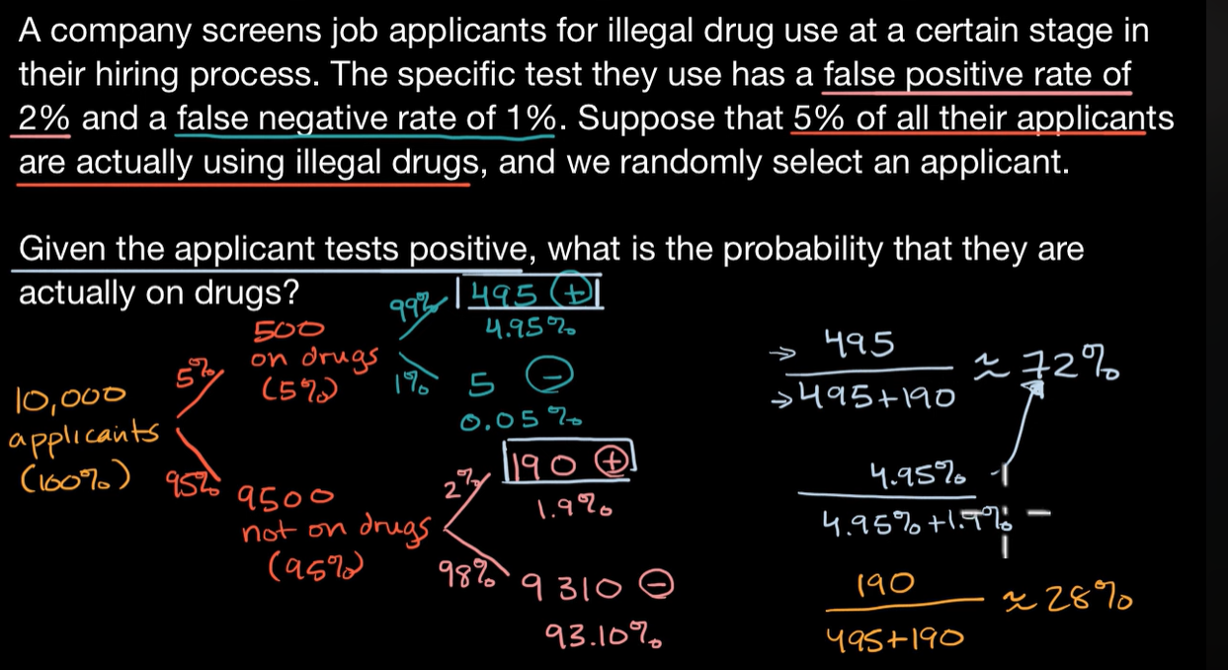
Conditional Probabilities - YouTube

✅ SUMMARY — Conditional Probability & Inference
1. What is Conditional Probability?
Conditional probability answers:
How does the probability of event A change if I know event B occurred?
This lets us update our beliefs when we gain partial information.
Notation:
$$P(A∣B)$$
(read “probability of A given B”).

2. The Core Formula
$$\boxed{P(A∣B)=\frac{P(A∩B)}{P(B)}}\text{(must have }P(B)>0)$$
Intuition:
Once you know B happened, your new universe is event B.
Now the only outcomes you consider are inside B.
Thus you count only inside B.

3. When Does B Affect A?
- Sometimes A and B are independent → knowing B does not change probability of A.
Example: two dice, event A = “first die = 3”, event B = “second die = 5”.
$$P(A∣B)=P(A)=1/6$$
- Sometimes learning B changes everything.
Example: A = “card is a spade”, B = “card is black”.
$$P(A)=1/4,P(A∣B)=1/2$$

4. Conditional Probability in Real-World Tests
Often:
- A = test result (e.g., positive)
- B = actual condition (e.g., has cancer)
We know:
- $P(\text{Test positive}∣\text{Has disease})$= sensitivity
- $P(\text{Test negative}∣\text{No disease})$= specificity
But what we truly want is:
$$\boxed{P(\text{Has disease}∣\text{Positive test})}$$
That is not the same!
This is an inverse problem solved using Bayes’ Theorem.

5. Bayes’ Theorem (preview)
$$\boxed{P(B∣A)=\frac{P(A∣B) P(B)}{P(A)}}$$
This is how we compute:
Probability someone has a condition given they test positive.

📘 Conditional Probability Cheat Sheet (Exam Ready)
Topic | Formula / Definition | Short Example
Basic probability of event A | $$P(A)=\frac{\#A}{\#Ω}$$ | 13 spades out of 52 cards → $1/4$
Conditional probability | $$P(A∣B)=\frac{P(A∩B)}{P(B)}$$ | Probability card is spade given it's black: $1/2$
Independence | A and B independent if: 1. $P(A∣B)=P(A)$, or 2. $P(A∩B)=P(A)P(B)$ | Two dice results
Complement rule | $$P(A^{c})=1-P(A)$$ | At least one 6 → $1-P(\text{no 6})$
Total probability | $$P(A)=\sum_{i}{}P(A∣B_{i})P(B_{i})$$ | Used before Bayes
Bayes' theorem | $$P(B∣A)=\frac{P(A∣B)P(B)}{P(A)}$$ | Probability sick given positive test
Updating beliefs | New info changes sample space | Knowing “sum = 6” changes dice probabilities

🔍 Examples from the lecture
1. Dice example (independent events)
A = “first die = 3”,
B = “second die = 5”.
Knowing B does nothing:
$$P(A∣B)=P(A)=1/6$$

2. Card example (dependent events)
A = “Spade”,
B = “Black”.
$$P(A)=\frac{1}{4},P(B)=\frac{1}{2}$$
Given black:
$$P(A∣B)=\frac{1}{2}$$

3. Medical test example
500 have cancer, 500 do not.
- True positive rate: $450/500=0.9$
- False positive rate: $100/500=0.2$
Goal:
$$P(\text{Cancer}∣\text{Positive})$$
Using Bayes:
$$P(C∣+)=\frac{0.9⋅0.5}{0.9⋅0.5+0.2⋅0.5}=\frac{0.45}{0.55}=0.818$$
So even with 90% sensitivity, probability of cancer given positive is ~82%.

Conditional Probability Example - YouTube
⚡ Key ideas recap
- Discrete uniform law: if a sample space is finite and all outcomes are equally likely,
$$P(A)=\frac{\#\text{(outcomes in }A\text{)}}{\#\text{(total outcomes)}}.$$
- For two fair six-sided dice: total outcomes $=6×6=36$. Represent outcomes as ordered pairs $(i,j)$.
- Conditional probability:
$$P(A∣B)=\frac{P(A∩B)}{P(B)}.$$
Equivalently, restrict attention to the conditional universe $B$and count outcomes inside $B$.
- Conditioning does not change relative likelihoods of equally likely outcomes: in the conditional universe all remaining outcomes are still equally likely.

✅ Worked solutions
Let $D$= event “doubles” (both dice show same number). Let $S_{≤4}$= event “sum ≤ 4”. Let $S$= event “at least one 6”. Let $K$= event “two dice land on different numbers”.
(a) $P(D)$— probability of doubles
Doubles are $(1,1),(2,2),…,(6,6)$: 6 outcomes.
$$P(D)=\frac{6}{36}=\frac{1}{6}.$$

(b) $P(D∣S_{≤4})$— doubles given sum ≤ 4
Method 1 (definition):
- Outcomes with sum ≤ 4: list them and count. They are
$(1,1),(1,2),(2,1),(1,3),(3,1),(2,2)$→ 6 outcomes.
- Among these, doubles are $(1,1)$and $(2,2)$→ 2 outcomes.
$$P(D∣S_{≤4})=\frac{2/36}{6/36}=\frac{2}{6}=\frac{1}{3}.$$
Method 2 (conditional universe): In the conditional world where sum ≤ 4 there are 6 equally-likely outcomes, and 2 are doubles → $2/6=1/3$.

(c) $P(S)$— probability at least one die is 6
Count all ordered pairs with at least one 6. You can count directly:
- First die = 6: $(6,1),(6,2),…,(6,6)$→ 6
- Second die = 6 but first ≠ 6: $(1,6),(2,6),(3,6),(4,6),(5,6)$→ 5
Total = $6+5=11$.
$$P(S)=\frac{11}{36}.$$
(Alternate quick: complement is “no 6 on either die” → $5/6×5/6=25/36$; so $1-25/36=11/36$.)

(d) $P(S∣K)$— probability at least one 6 given the dice are different
- Event $K$= dice different → exclude the 6 diagonal outcomes (doubles). So $\#K=36-6=30$equally-likely outcomes.
- Count outcomes in $K$that have at least one 6. From (c) we had 11 total outcomes with a 6; among these 11, the double $(6,6)$ is excluded in $K$. So in $K$there are $11-1=10$ favourable outcomes.
$$P(S∣K)=\frac{10}{30}=\frac{1}{3}.$$
(Alternate: list all ordered pairs with a 6 excluding (6,6).)

🧠 Quick checks / tricks
- Complement method often easier for “at least one” events: $P(\text{at least one 6})=1-P(\text{no 6})$.
- When conditioning, either compute $P(A∩B)/P(B)$or work in the conditional universe $B$and count outcomes there.
- Keep track if outcomes are ordered (they are for two dice: $(i,j)$differs from $(j,i)$unless $i=j$).

✍️ Two practice problems (similar)
Practice 1. Roll two fair six-sided dice.
- What is the probability the sum equals 7?
- Given the sum is at least 5, what is the probability the sum equals 7?
Practice 2. Roll two fair six-sided dice.
- What is the probability that the maximum of the two rolls equals 5? (Hint: outcomes where both ≤5, and at least one =5)
- Given the first die is odd, what is the probability the maximum is 5?

